ACADEMIC YEAR: 2023-24
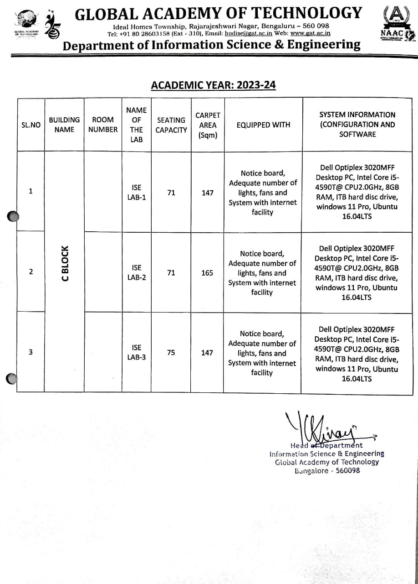
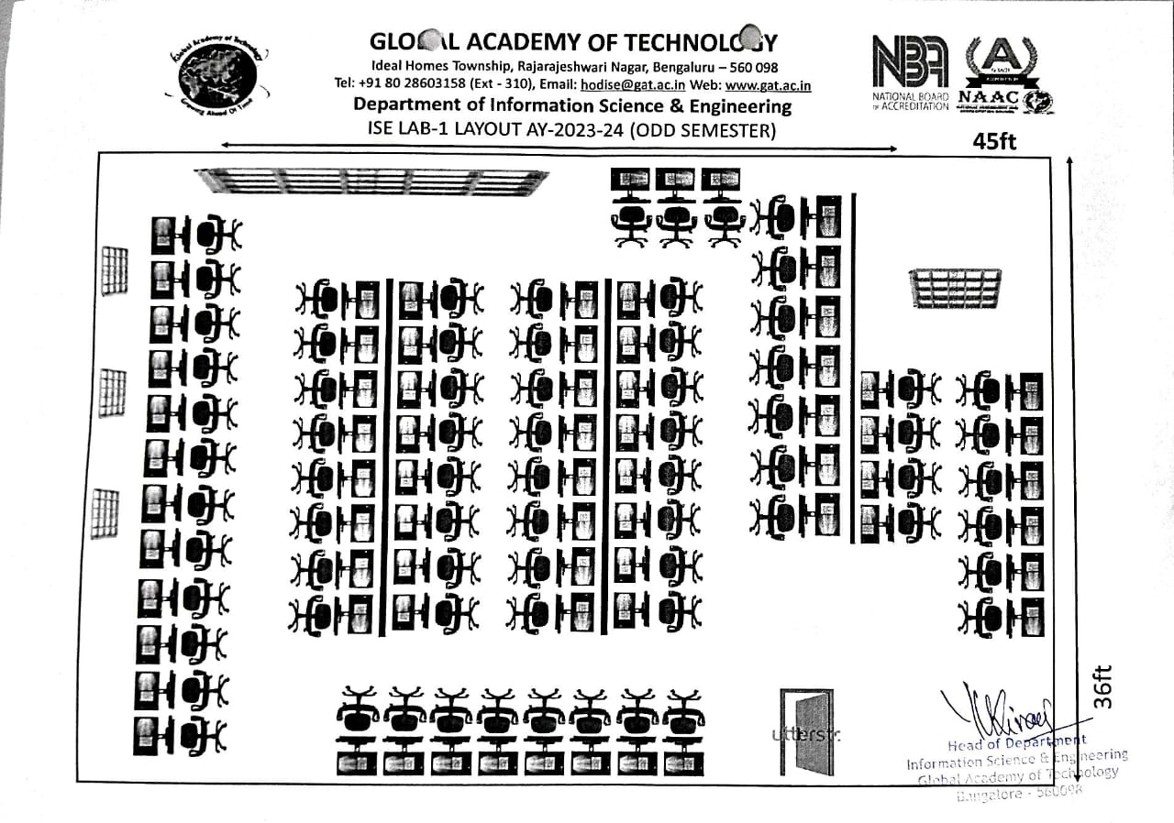

ACADEMIC YEAR: 2023-24
Class Room Details & Staff Room Details

